1. **Get first and last elements from LinkedList example**

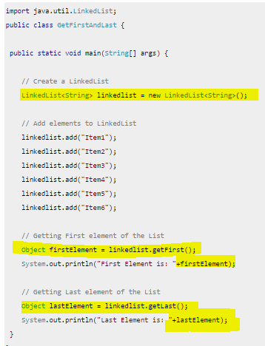

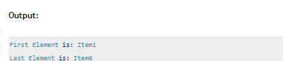

1. **How to iterate the linked list**

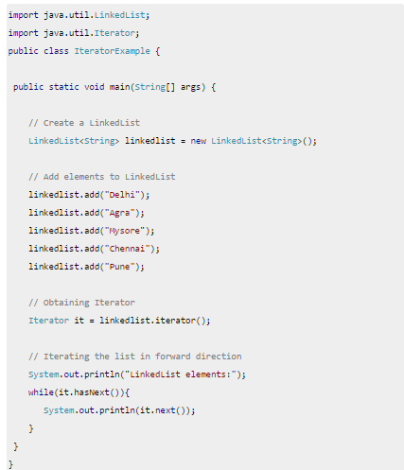

1. **Check if a particular element exists in LinkedList example**

